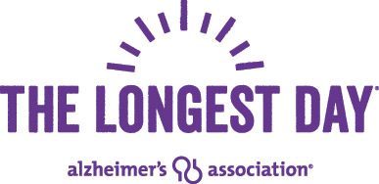
Please Pledge to Help Me in the Fight to End Alzheimer’s!
I am participating in the Longest Day, a team fundraising event to support the Alzheimer’s Association. Individual events take place throughout the year. Then, on the summer solstice, the longest day of the year, we unite to honor those living with dementia and their caregivers, for whom every day is the longest day. Please consider helping me by pledging your support below.
My name is: ____________________________________________________________________
- I am a Longest Day individual fundraiser
- I am part of team __________________
I am committed to:
- A mile a day starting date _________ end date_____________
- 10,000 steps per day starting date _________ end date_____________
- An hour of activity every day starting date _________ end date_____________
- Another Activity/Event: _____________________________________________________
I am doing this to honor: __________________________________________________________
_______________________________________________________________________________
_______________________________________________________________________________
How can you help?
- Please pledge a donation on my commitment described above as follows:
____$ 10 _____$ 20 ____$ 50 ____$ 100 _____other amount

- Credit card donations can be made online at: www.alz.org/TLD. Click find a participant at top right then enter my name.
- Checks should be payable to Alzheimer’s Association. Reference “TLD 2018” and return me.
My Contact Information:

Participant First Name: _____________________Last name: _____________________________

Address: _______________________________ City____________ State_______ Zip__________

Please contact me with any other questions at: Tel: _____________ Email: _____________
A tax letter will be mailed to all online donors and check donors with an address on their check.
Thank You For Your Support!

